**HUMAN COMPUTER INTERFACE FOR DEVICE COMMUNICATION**

**SULEIMAN ISHAKA**

**(ST/CS/ND/20/074)**

**A SEMINAR REPRESENTED TO THE DEPARTMENT OF COMPUTER SCIENCE, SCHOOL OF SCIENCE AND TECHNOLOGY, FEDERAL POLYTECHNIC MUBI, ADAMAWA STATE, NIGERIA**

**NOVEMBER, 2022**

**HUMAN COMPUTER INTERFACE FOR DEVICE COMMUNICATION**

**SULEIMAN ISHAKA**

**(ST/CS/ND/20/074)**

**A SEMINAR REPRESENTED TO THE DEPARTMENT OF COMPUTER SCIENCE, SCHOOL OF SCIENCE AND TECHNOLOGY, FEDERAL POLYTECHNIC MUBI, ADAMAWA STATE, NIGERIA**

**IN PARTIAL FULFILLMENT OF THE REQUIREMENTS FOR THE AWARD OF NATIONAL DIPLOMA (ND) IN COMPUTER SCIENCE**

**NOVEMBER, 2022**

**Abstract**

*In this seminar we present a new technology system along with Human Computer Interaction (HCI) model, where interaction with technology is dissolved into a day-today activity. In this type of HCI model a computer input and output are being displayed in a bigger and better size with the use of the free space on the air. Usually, in urban and rural areas people use the screen of their gadgets to display both the input and output on a mobile phone screen, computer screen, projector, etc. Some of the things to be displayed may not be visibly viewed due to the minimization in size and space, Holographic display pop out the input and output display in a clearer and better manner. The impact of this technology is seen the society in areas like, schools, hospitals, banking, marketing, families, security, etc*

**Keywords:** Human-system interface, human-machine interface, man-machine interface, Hologram.

**Introduction**

Nowadays, advanced technologies are growing faster wherein each technology is renewed with implementation of new one. The current trending display technology most commonly used in gadgets such as tablets, smart phones, etc., is the touch-screen display, which will become outdated in the near future. Holography is the advanced display technology, which replaces the touch screen technology to resolve the problems and to make lives more comfortable. Therefore, this article is intended to give an idea of the holography technology, which transmits or displays the information without using a projector or the screen. By using this holography technology, we can display the images directly on the open space, human retina and also to the human brain (Alex, 2019).

During the year 2013, this display came into progress by the implementation of products like virtual reality headsets, retinal displays and holographic videos. Lack of space is the major drawback for most of the screen displays. This problem can be overcome by the use of holography display.

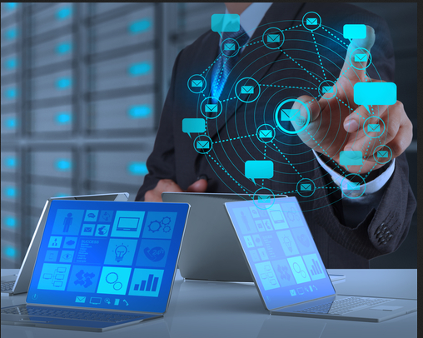

Figure 1: Holographic technology (Alex, 2019).

**Holographic Technology**

According to Blessing (2014), Holography is an interactive projection technology developed to solve the problems related to the device miniaturization of the modern communication technologies. The lack of space on screen based displays provides an opportunity for the development holography displays. Holography technology display has no screen and it can be defined as a display used to transmit any data such as pictures or videos without the help of screens.

**Impact of Holographic Technology in Society**

Holographic technology has an impact role to play in the society coping with the fast advancement in technology around the world.

Michael (2017), with the current trending display technology most commonly used in gadgets such as tablets, smart phones, laptops, palmtops etc., one, most at times need to zoom and zoom in what he/she wants to view due to the lack of space, and small in size. But with the introduction of hologram, the case is settled as you have enough space on the air to view anything.

Medically speaking Alex (2019), explained the effect of brightness to the retina of humans most especially the old, which hologram is here to help again with the space in the air making the brightness of hologram no effective.

**Types of Holography**

Holography technology is divided into three main categories:

1. Visual Image Display
2. Retinal Display
3. Synaptic Interface

The first category, visual image is defined as the things that can be seen by the human eye such as holograms. Nanayakkara (2013) the second category, retinal display – the name itself- indicates the display of image directly onto the retina. Perrault and Simon (2013), the third category, synaptic reference which means sending information directly to the human brain. Let us look on in detail about these three display types.

**Visual Image Display:** The visual image is a type of screen less display, which recognizes any type of image or thing with the help of the human eye (Blessing, 2014). The following are few examples of the visual image display: holographic display, virtual reality goggles, heads up display, etc. The working principle of this display states that the light gets reflected by the intermediate object before reaching the retina or the eye.

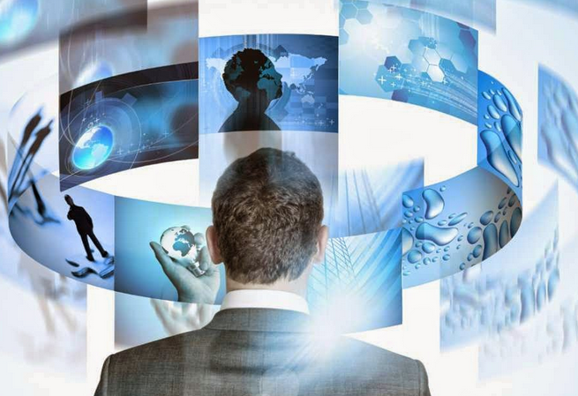

Figure 2: Visual Image Display (Blessing, 2014).

The intermediate object can be a hologram, Liquid Crystal Displays (LCD)s or even windows.

By using the components like Helium Neon Laser, an object, a Lens, a holographic film and mirror, the Holographic Displays display the three dimensional (3D) images. A 3D image will be projected and appears to be floating in the air whenever the laser and object beams overlaps with each other. This display can supply accurate depth cues and high-quality images and videos that can be viewed by the human eyes without any need of special observation devices. Based on the colors of the laser projector, images are formed in three distinct planes. Holographic displays are commonly used as an alternative to screens.

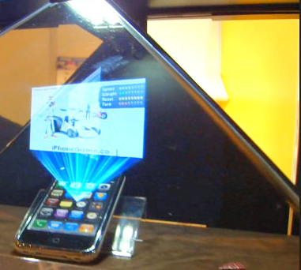

Figure 3: Visual Image Display (Blessing, 2014).

Heads up display are also named as transparent displays. These displays are applied in different applications such as aero-planes, computer games and automobiles, etc. Many of the users do not need to look away from their field of view because the device displays the information on a windshield. An ordinary head up display comprises of following components: a projector unit, combiner and a computer. The projector unit projects the image, and the combiner redirects the displayed image by that projected image, and the field of view are seen simultaneously (Blessing, 2014).

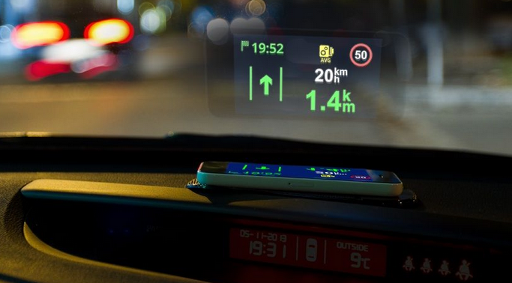

Figure 4: Visual image display (Blessing, 2014).

The main advantage of visual image displays is creating and manipulating the images up to any size (Caleb, 2015). In this category of displays, multiple bitmaps can be composited together in the object mode and, in the image mode, manipulation takes place. In this display system, Eye files are created which consists of all the images that are loaded. The EYE file creates a ‘Export Project Command’ in the file. These commands in EYE file provide a provision to save any sort of unsaved images in the form of bitmaps into it. A common catalog is created to place the browsed images from ‘Export Editor Command’ in the ‘EYE’ file.

**Retinal Display:** The second category of advancement in display system, retinal display as the name itself indicates the display of image directly onto the retina. Instead of using some intermediate object for light reflection to project the images, this display directly projects the image onto the retina. The user will sense that the display is moving freely in the space. Retinal display is commonly known as retinal scan display and retinal projector. This display allows short light emission, coherent light and narrow band color. Let us know about this display with the help of the following block diagram.

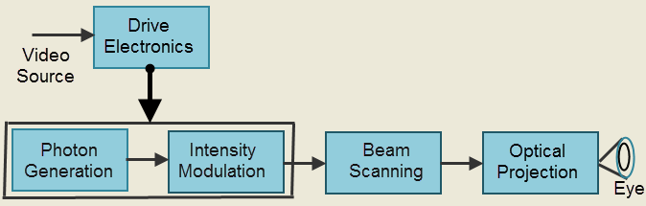

Figure 5: Retinal display (Caleb, 2015).

The block diagram of the virtual retinal display consists of following blocks: photon generation, intensity modulation, beam scanning, optical projection and drive electronics. Photon generation block generates the coherent beam of light; this photon source makes use of the laser diodes as coherent source with retina display to give a diffraction onto the retina of the human eye. The light generated from photon source is intensity modulated. The intensity of the light beam gets modulated to match the intensity of the image.

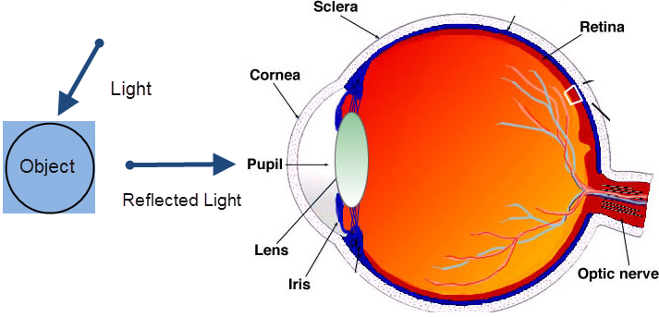

Figure 6: Retinal display (Caleb, 2015).

The modulated beam gets scanned by the beam scanning. By using this scanning block, the image is placed onto the retina. In this beam scanner, two types of scanning modes take place: raster mode and vector mode. After the scanning process, optical projection takes place for projecting a spot-like beam onto the retina of the eye. The spot focused on the eye is sketched as an image. A drive electronics placed on the photon generator and intensity modulator is used for synchronization of the scanner, modulator and coming video signal. These displays are made available in the market by using MEMS technology.

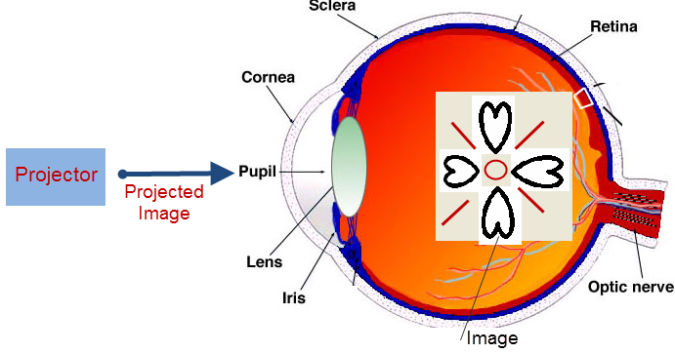

Figure 7: Retinal display (Caleb, 2015).

**Synaptic Interface:** The third category, synaptic interface means sending information directly to the human brain without using any light. This technology is already tested on humans and most of the companies started using this technology for effective communication, education, business and security system. This technology was successfully developed by sampling the video signals from horse crab eyes through their nerves, and the other video signals are sampled from the electronic cameras into the brains of creatures.

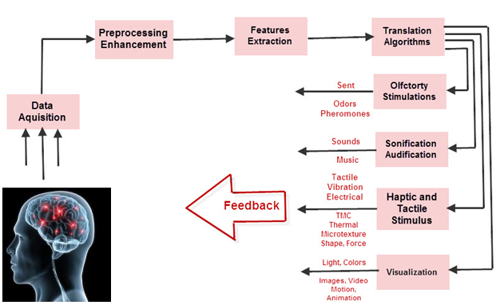

Figure 8: Synaptic interface (Caleb, 2015).

The brain computer interface allows direct interaction between the human brain and external devices such as computer. This category can also be known by different names such as human machine interface, synthetic telepathy interface, mind machine interface and direct neural interface.

**Conclusion**

In conclusion, it can be said that HCI has impacted the learning environment as it has impacted other corresponding environments. The impact HCI has in the learning environment has been positive, however, the downside to it was that it created room for individuals to depend on it. The positive side to this phenomenon is that becoming familiar with all HCI concepts and appreciating them, improves a user’s interaction and this brings about efficiency.

Lastly, as said earlier, not only should a computer be cognitively fit, but also the user should be cognitively/physically prepared to use the system before getting in physical contact with a system.

# Recommendations

1. The first recommendation is that since it has been established that computer reduces drudgery and improve learning outcomes, HCI related courses should be introduced not only for the computer and science-related courses but also for every academic pursuit.
2. It is also recommended that an investigation be carried out on the degree of efficiency HCI has impacted in a learning environment. This is because of its benefits to them (students and staff) so that they are flexible and easily adapt without any substantial amount of interruption to their learning.

**Reference**

Alex, G. (2019). The Opportunities and Limitations of Human Computer Interaction in Virtual and Augmented Reality. *International Journal of Computing, 2 (9),* 78-98.

Blessing, A. (2014). Human–computer interaction, foundations and new paradigms. *Journal of Visual Languages & Computing*, *4*(2), 122-134.

Caleb, P. (2015). High-fidelity prototyping of interactive systems can be formal too. *International Journal on Human-Computer Interaction*, 11(3), 667-676.

Michael, R. (2017). *Readings in Human Computer Interaction: toward the year 2000*. Elsevier.

Nanayakara, G. (2013). March. Human-computer interaction: process and principles of human computer interface design. *International Journal on Computer and Automation Engineering*, 4(12), 230-233.

Perrault, J. & Simon, J. (2013). Mental models in human-computer interaction. *International Journal of human-computer interaction*, 6(13), 45-65.